Invitation – Caring Communities Platform Workshop #5 (Moldova)
Home-Based Socio-Medical Services in Moldova: Legislation, Digitalization, and Specialized Care
Date: 17 June 2025
Time: 09:00 – 11:00 CET
Format: Online (Zoom – link will be sent to registered participants https://us02web.zoom.us/j/88629977464?pwd=it304aOu47bBXrI1PszD3nwUMkL7sg.1
Meeting ID: 886 2997 7464 Passcode: 894762)
Focus country: Republic of Moldova

About the Event
We are pleased to invite you to the 5th transnational workshop of the Caring Communities Platform, spotlighting Moldova as a country of transformation—where public policy and grassroots initiatives come together to shape inclusive social care.
Our focus will be on elderly care, dementia services, disability support, and mobile outreach, all framed by Moldova’s evolving strategy of social inclusion and decentralised service delivery.
You will hear directly from national policymakers, municipal practitioners, and community innovators.

🗓️ Draft Agenda (CET)
09:00–09:10 | Welcome & Introduction
Framing remarks by the Platform Coordination Team

09:10–09:30 | Moldova’s National Path to Inclusive Care - Harmonization of the national legal framework on homecare with EU requirements
🗣️ Oleg Barcari
Head of Directorate for Social Assistance Policies for Low-Income Families and the Elderly, Ministry of Labour and Social Protection
On the “Cash Plus” model and national efforts to embed active social inclusion into poverty reduction and long-term care.
9.30-9.35 Q&A and Reflections

09:35–9:55 | Local Practice in Dementia and Elderly Support - Caring for People with Dementia: Understanding, Empathy, and Effective Intervention
🗣️ Vladislava Tcaci
Senior Specialist, Municipality of Strășeni
Practical lessons from municipal service delivery for older people and people with dementia—bridging NGO experience and public policy. Social services expert with over 16 years of experience in managing and directly providing care services for elderly persons, including those diagnosed with various forms of dementia. She coordinates AO “Neoumanist”, which provides homecare, day centre services, and mobile teams.
9.55-10.00 Q&A and Reflections

10:00–10:20 | Digitalization of socio-medical homecare services: experiences and future perspectives from Moldova
🗣️ Representative of AO Casmed –
– A non-profit organization with over 11 years of experience in developing socio-medical homecare services in Moldova. CASMED operates in more than 100 localities and implements innovative models such as Kinaesthetics and age-friendly community approaches.
10.20-10.25 Q&A and Reflections

10:25–10:45 | Palliative care in Moldova: techniques for supporting patients in terminal stages
🗣️ Natalia Carafazi
Medical doctor and Executive Director of Hospice Angelus Moldova
She oversees the provision of free services to terminally ill patients (over 2,500 annually), as well as rehabilitation and post-mastectomy support initiatives.
10:45–10:50 | Q&A and Reflections
10:50–11:00 | Wrap-Up & Outlook
Preview of the next workshop in Austria (📅 23 September 2025) and final takeaways

💬 Languages
Main language: English
Interpretation to Romanian and Hungarian upon request

📌 Register here: https://forms.office.com/e/9jCLEGBjVy?origin=lprLink
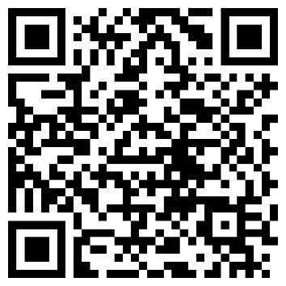
We look forward to welcoming you online—
Let’s keep building caring communities across borders.

